JENKINS Assignment-04.

1) Setup jenkins CICD pipeline using freestyle job using Docker containers using below
code.
https://github.com/betawins/hiring-app.git
Stages:
1) Git Clone
2) Sonarqube Integration
3) Maven Compilation
4) Nexus Artifactory
5) Slack Notification
6) Deploy On tomcat
2) Setup a jenkins CICD pipeline using Declarative pipeline using feature-1.1 branch.
https://github.com/betawins/sabear_simplecutomerapp/tree/feature-1.1
stages:
1) Git Clone
2) Sonarqube Integration
3) Maven Compilation
4) Nexus Artifactory
5) Slack Notification
6) Deploy On tomcat
3) Setup a jenkins CICD pipeline using Scripted pipeline using feature-1.1 branch.
https://github.com/betawins/sabear_simplecutomerapp/tree/feature-1.1
stages:
1) Git Clone
2) Sonarqube Integration
3) Maven Compilation
4) Nexus Artifactory
5) Slack Notification
6) Deploy On tomcat
4) Write sample skeleton of pipelines.
5) Create a parametirized job in jenkins.
https://github.com/betawins/spring3-mvc-maven-xml-hello-world-1.git
6) Setup one slave machine for jenkins.
GitHub - betawins/hiring-app
GitHub - betawins/sabear_simplecutomerapp at feature-1.1
GitHub - betawins/spring3-mvc-maven-xml-hello-world-1: Maven + Spring 3 MVC
hello world example (XML)
1) Setup jenkins CICD pipeline using freestyle job using Docker containers using below
code.
https://github.com/betawins/hiring-app.git
Stages:
1) Git Clone
2) Sonarqube Integration
3) Maven Compilation
4) Nexus Artifactory
5) Slack Notification
6) Deploy On tomcat
=====================================================================
1. GIT CLONE and 2. SONARQUBE INTEGRATION
a. Installed jenkins in jenkins-ec2 take t2.large
b. Created sonarqube-ec2 take t2.large and installed docker and pull image of
sonarqube.
yum -y install docker
systemctl start docker
docker pull sonarqube (only download image.)
docker run -d --name sonarqube -p 9000:9000 sonarqube:lts
(download (if needed) + create + start container.)
Docker ps

d. In jenkins master install sonarqube-scanner plugin
Go to Manage Jenkins → System.
Scroll to SonarQube servers section.
Add:
● Name → SonarQube
● Server URL → your SonarQube URL (example: http://<sonarqube-
server-ip>:9000)
● Authentication Token → generate one in SonarQube (My Account →
Security → Tokens).
e. Now in jenkins home page, create a job hiring-app and enter the analysis properties
f. https://github.com/betawins/hiring-app.git
g. The repo is in main branch same need to configure in job also.
sonar.projectKey=Sabear
sonar.projectName=Sabear
sonar.projectVersion=1.0
sonar.sources=/var/lib/jenkins/workspace/$JOB_NAME/src/
sonar.binaries=target/classes/com/visualpathit/account/controller/
sonar.junit.reportsPath=target/surefire-reports
sonar.jacoco.reportPath=target/jacoco.exec
sonar.java.binaries=src/main/java/com/visualpathit/account/
sonar.projectKey=Sabear
sonar.projectName=Sabear
sonar.projectVersion=1.0
sonar.sources=/var/lib/jenkins/workspace/$JOB_NAME/src/
sonar.binaries=target/classes/com/visualpathit/account/controller/
sonar.junit.reportsPath=target/surefire-reports
sonar.jacoco.reportPath=target/jacoco.exec
sonar.java.binaries=src/main/java/com/visualpathit/account/

Now start build

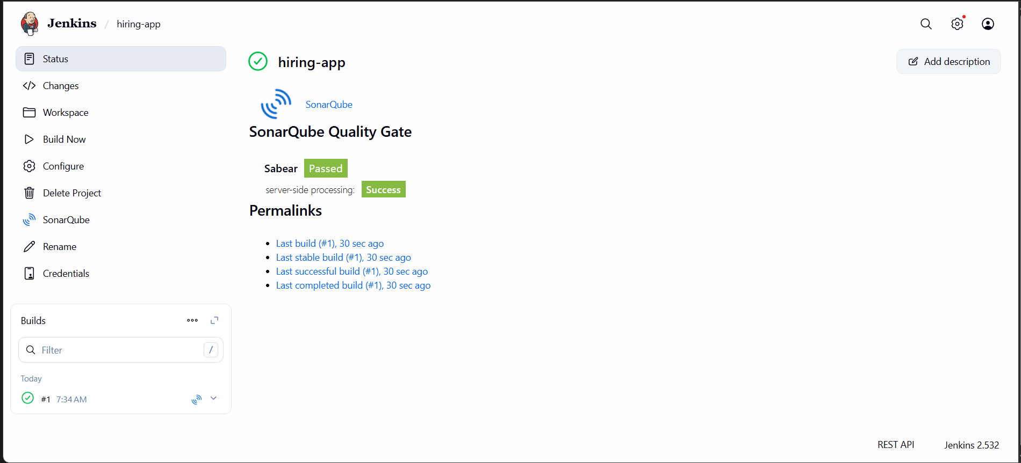

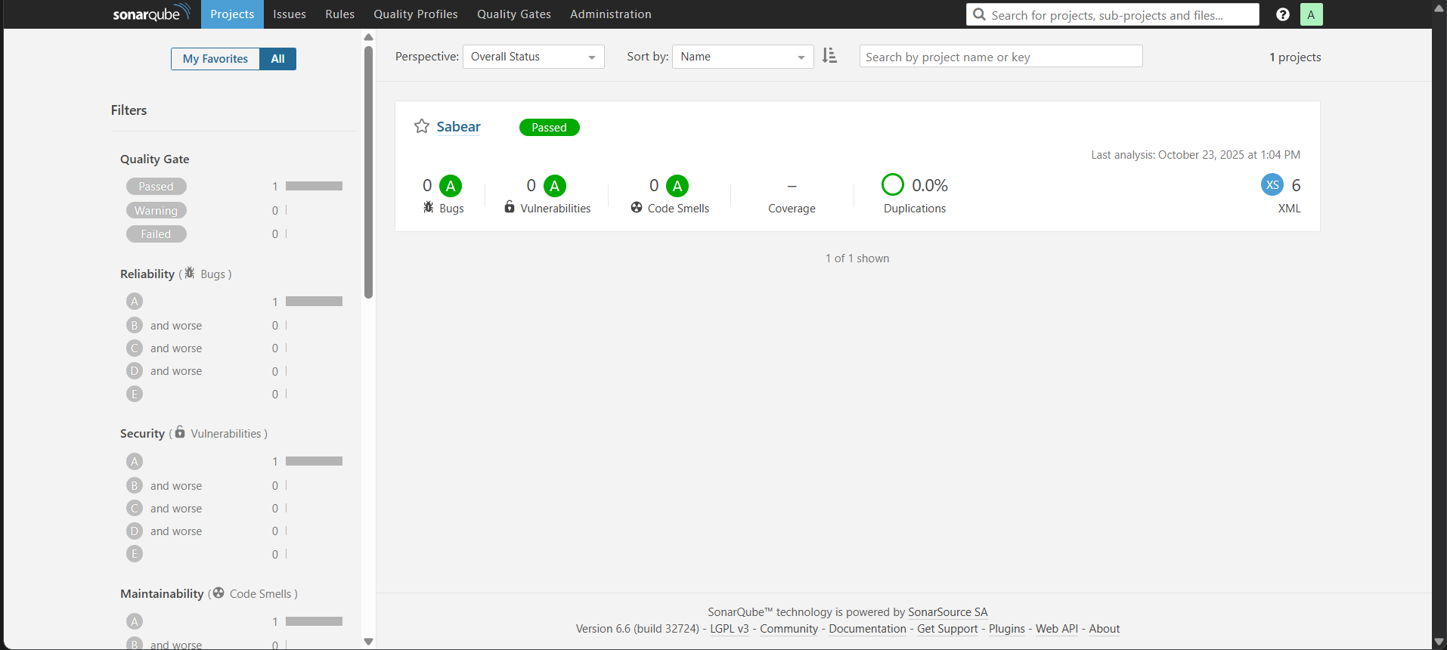

3. MAVEN COMPILATION
a. download apche maven in jenkins master
cd /opt
wget https://dlcdn.apache.org/maven/maven-3/3.9.11/binaries/apache-maven-3.9.11-bin.tar.gz
b. Now extract the tar file
tar -xvf apache-maven-3.9.11-bin.tar.gz
c. cd apache-maven-3.9.11/bin
d. 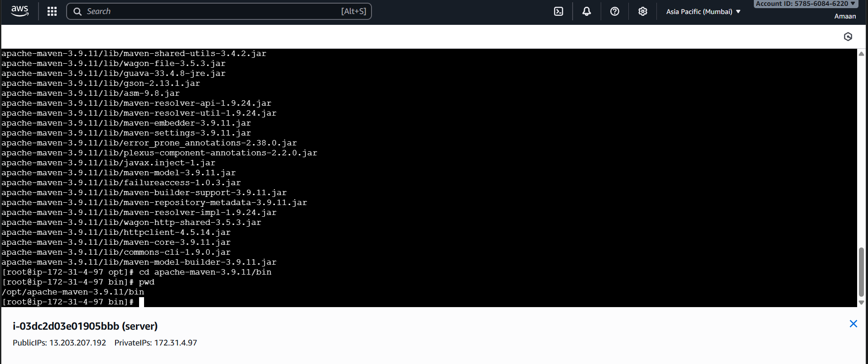
e. Store global variable in script to access maven –version
f. In jenkins server edit the file and some details → come to root →
vi .bash_profile
MVN_HOME=/opt/apache-maven-3.9.11/bin
PATH=$PATH:$HOME/bin:$MVN_HOME
export PATH
g. 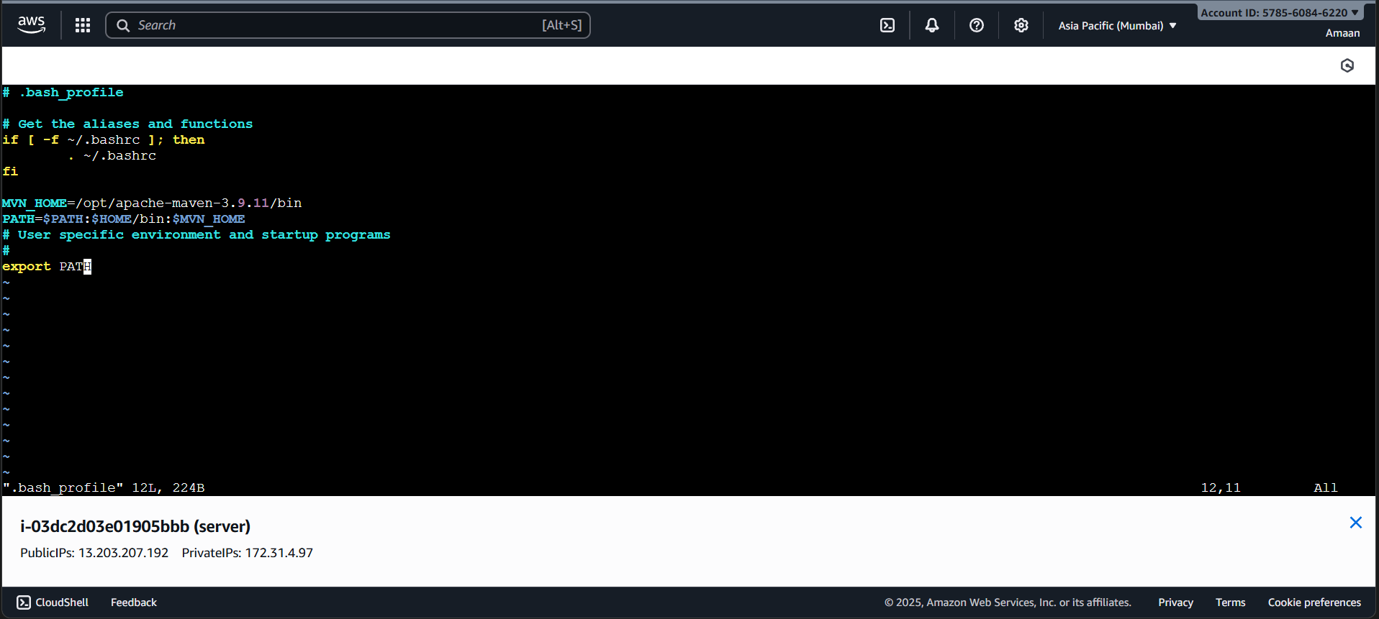
h. Now restart the file and check.
source ~/.bash_profile
echo $MVN_HOME
mvn -version
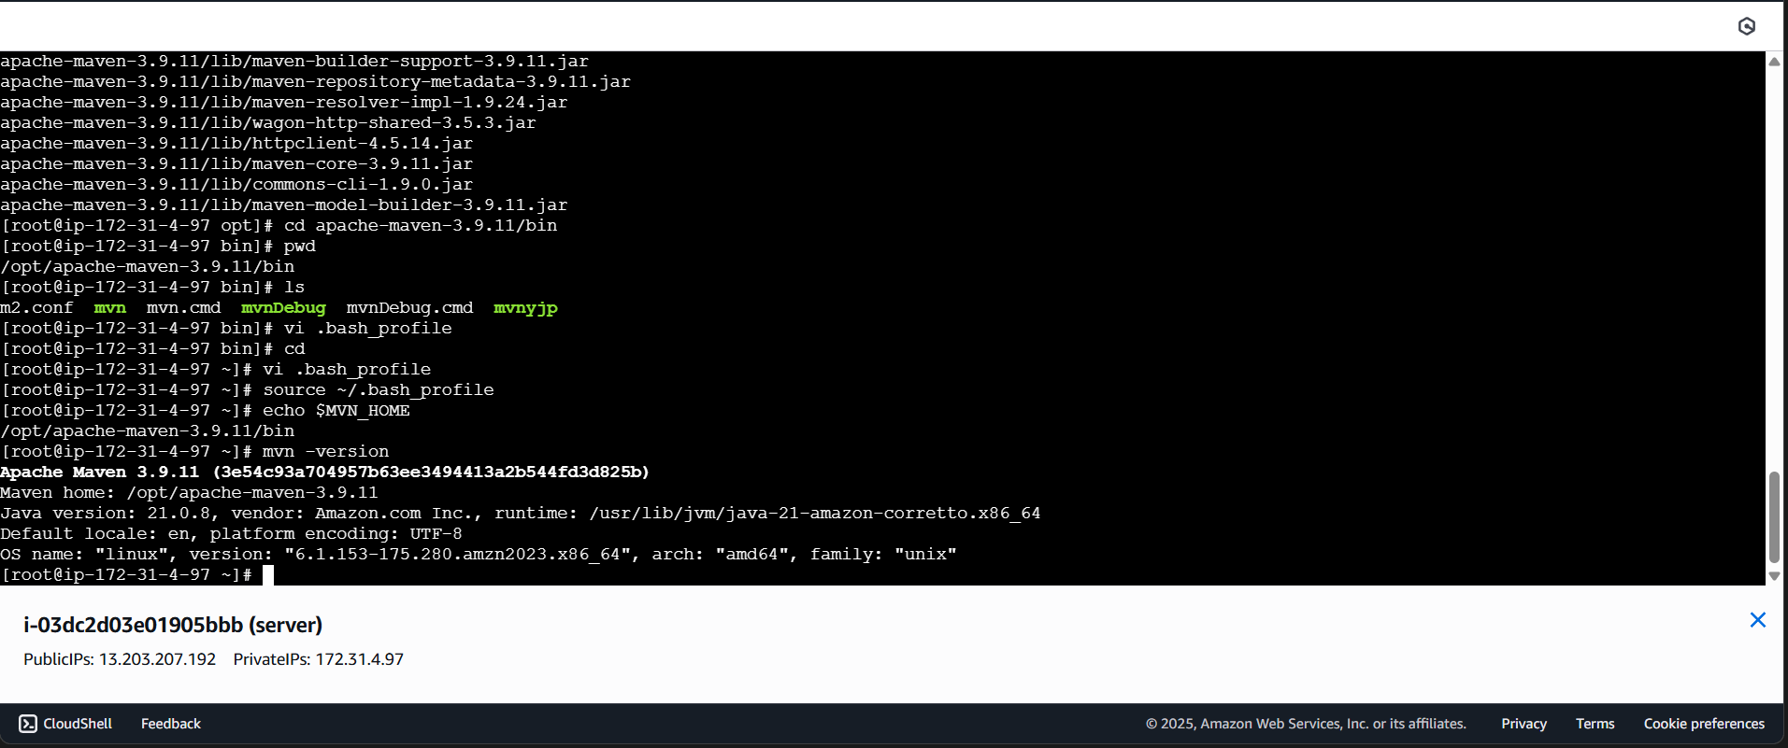

Now goto manage jenkins --> tools --> maven --> /opt/apache-maven-3.9.11

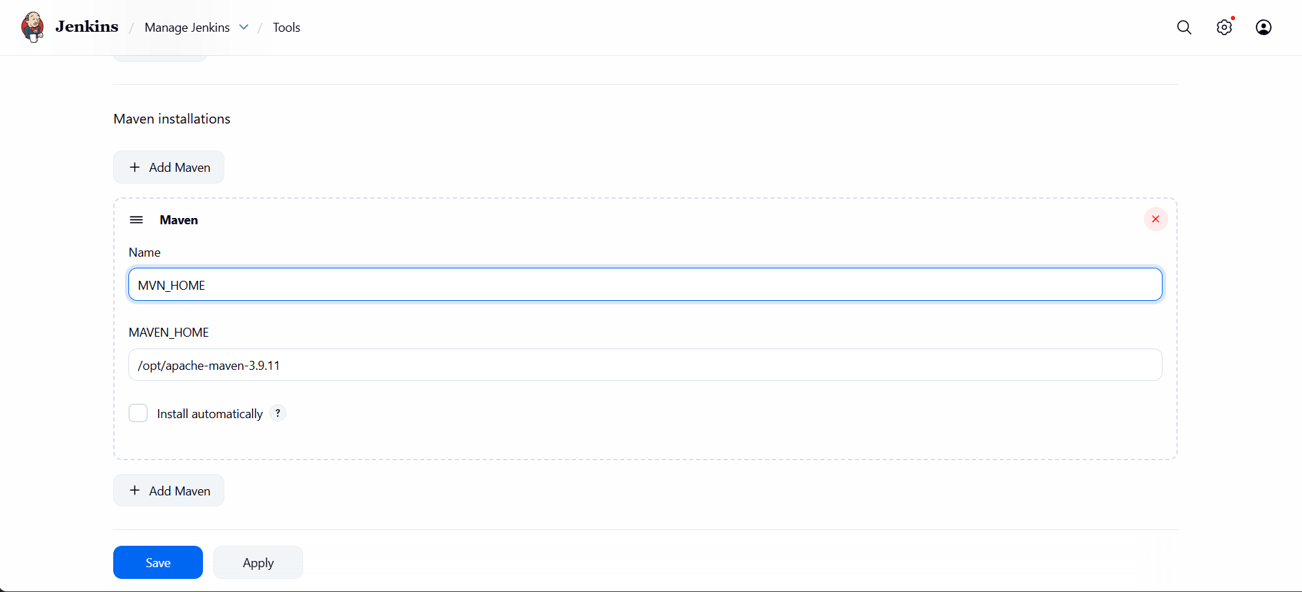

l. goto job --> add build step --> select invoke top maven -- goals(clean install)
m. Then it will clean and create a package.
n. 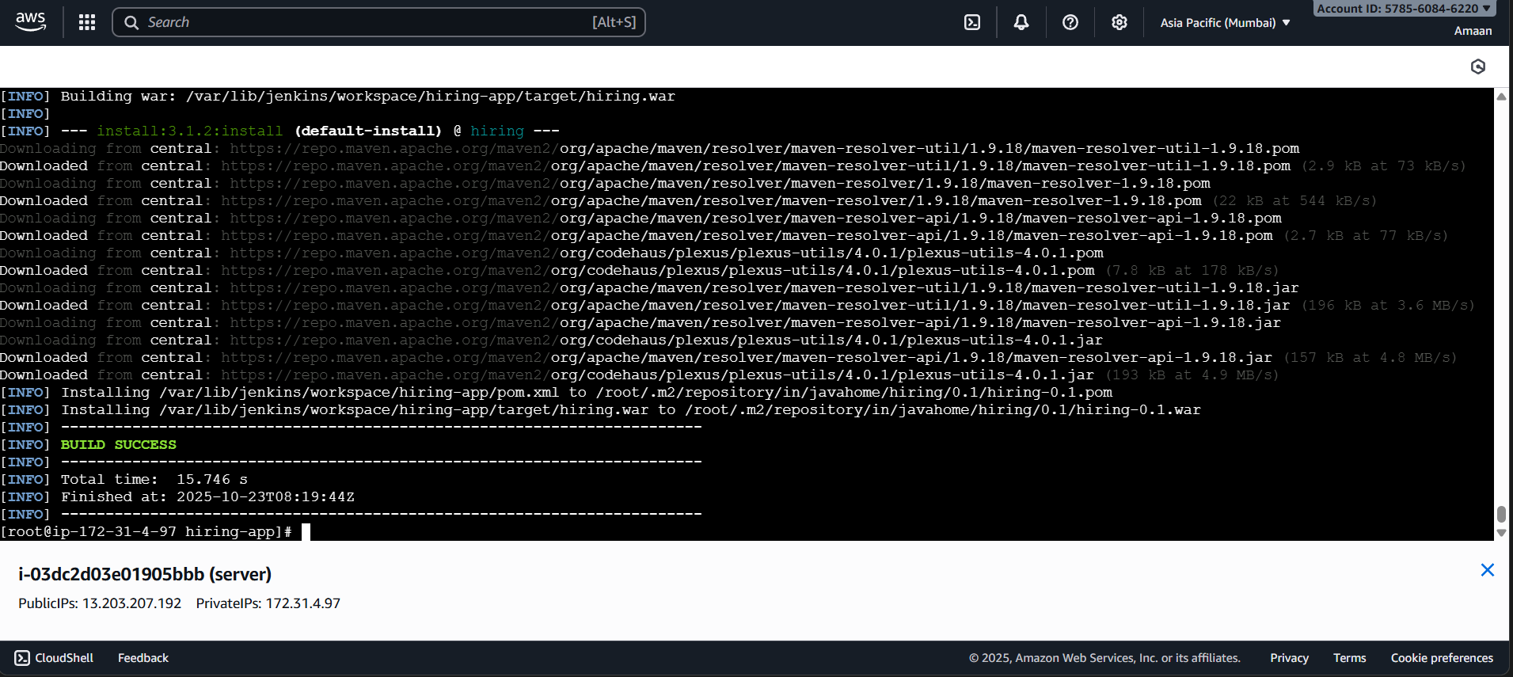
o. Now run the build then git clone done, sonarqube integration done, then maven
created a war file.
p.
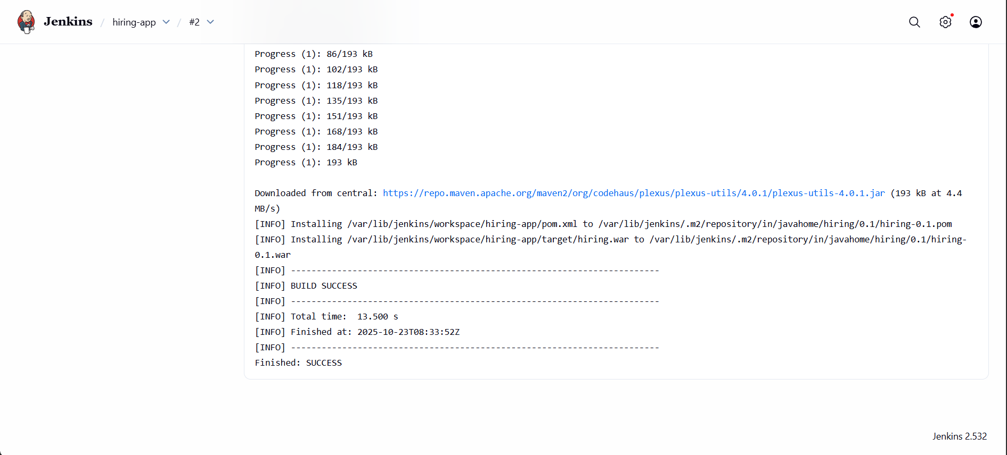

q. /var/lib/jenkins/.m2/repository/in/javahome/hiring/0.1/hiring-0.1.war
r. In jenkins server → cd /var/lib/jenkins/workspace/hiring-app/target
s. 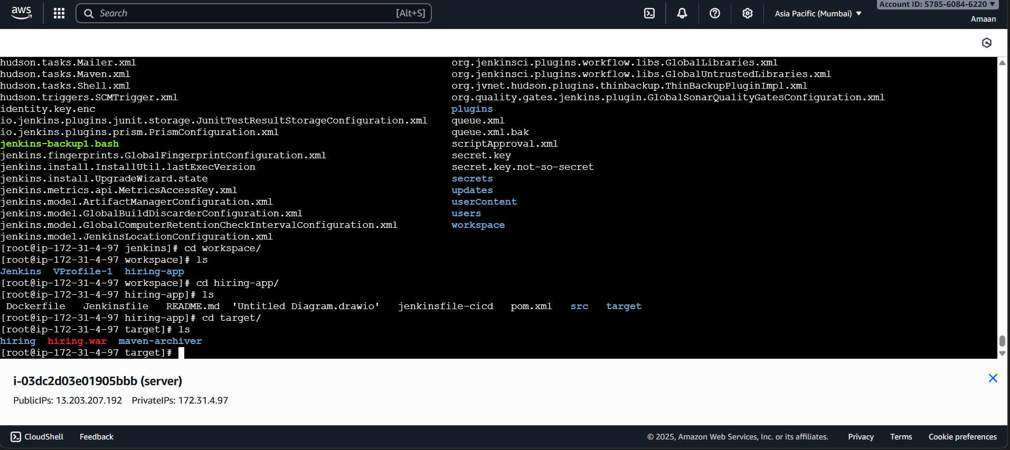

t. (in git repo we have a file pom.xml it connect to maven and download all packages)

- We can check dependencies in jenkins server
Cd /var/lib/jenkins/.m2/repository
ll
2. 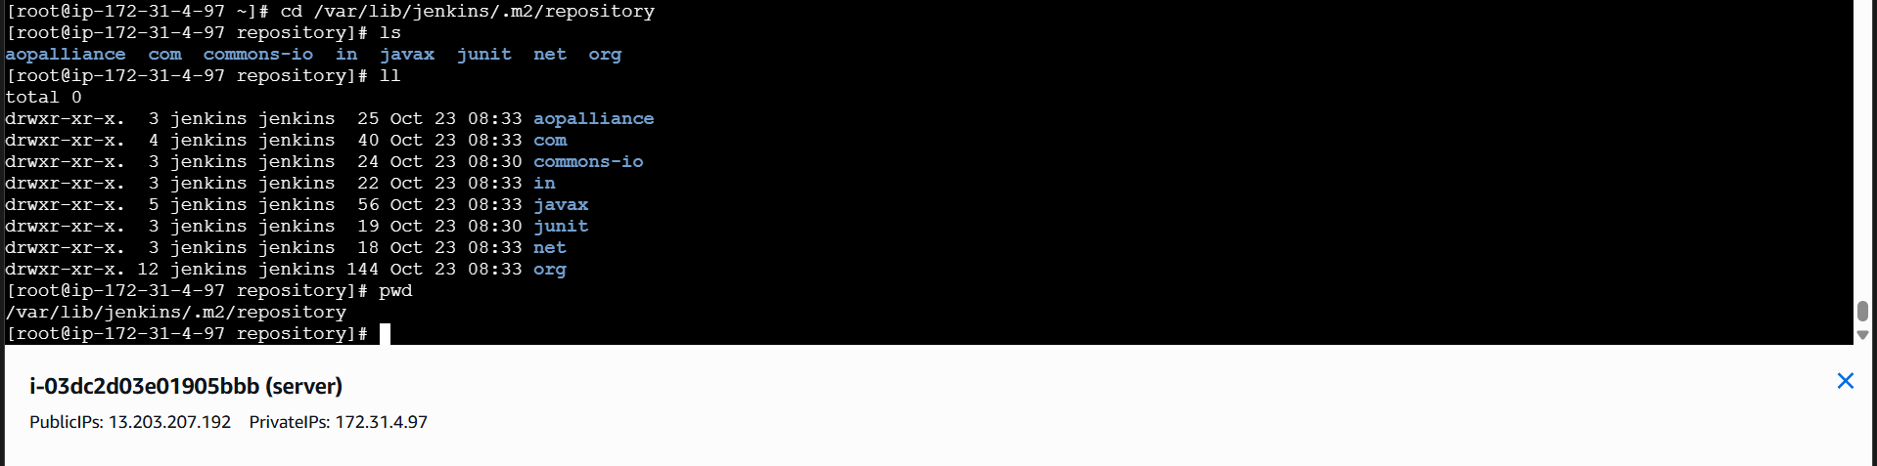

4) Nexus Artifactory

1. Now create nexus-ec2 with t2.large
install java → yum install -y java-1.8*
2. And now download nexus
cd /opt
wget https://sonatype-download.global.ssl.fastly.net/nexus/3/nexus-3.0.2-02-
unix.tar.gz
tar -zxvf nexus-3.0.2-02-unix.tar.gz
mv /opt/nexus-3.0.2-02 /opt/nexus
3. In nexus ec2 → cd /opt/nexus/bin
4. vi nexus.rc
5. Remove # and Add → run_as_user="ec2-user" 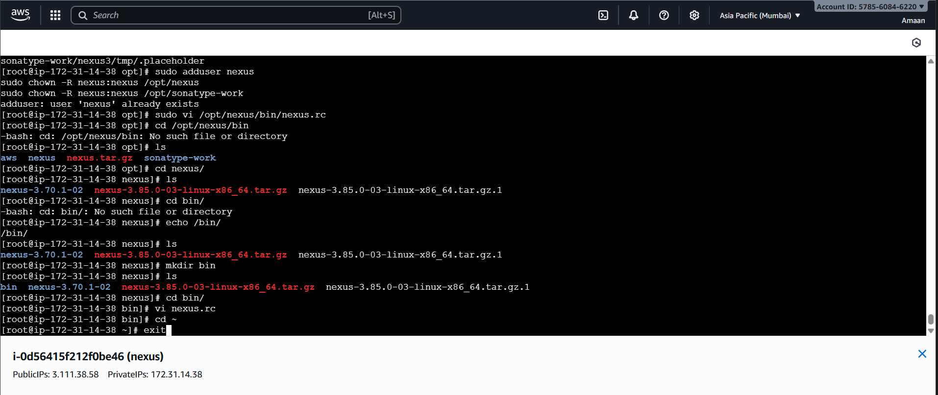
6. Now switch to ec2-user give ownership and start and check status.
7. cd /opt
8. Give permissions → sudo chown -R ec2-user:ec2-user nexus
9. cd /opt/nexus/bin
10. ./nexus start
11. ./nexus status
12. Locate the Executable
Run:
bash
cd /opt/nexus/nexus-3.70.1-02/bin
ls
You should see a file called nexus.
If yes, make it executable:
bash
chmod +x nexus

Start Nexus
You can now start Nexus using:
bash
./nexus start
To stop it later:
bash
./nexus stop
If this works, access it in your browser:
text
http://<EC2-Public-IP>:8081
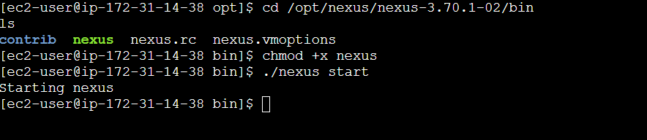
13.Check in browser with public ip of nexus-ec2 it runs on port number 8081
http://65.2.171.173:8081/
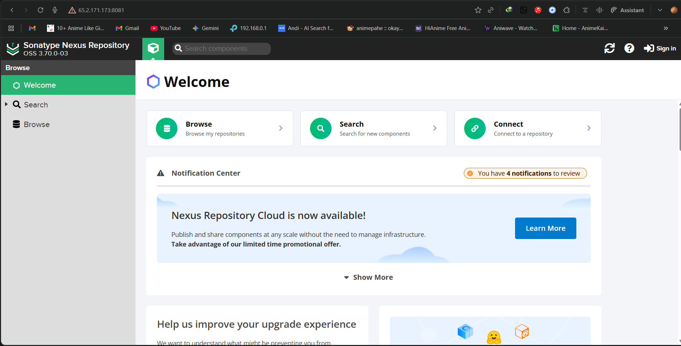
- Now sign in with login details → admin , admin123

Integrate jenkins with nexus

- Download plugin “nexus artifact uploader” in jenkins
- Now go to your job → configure → build step → nexus

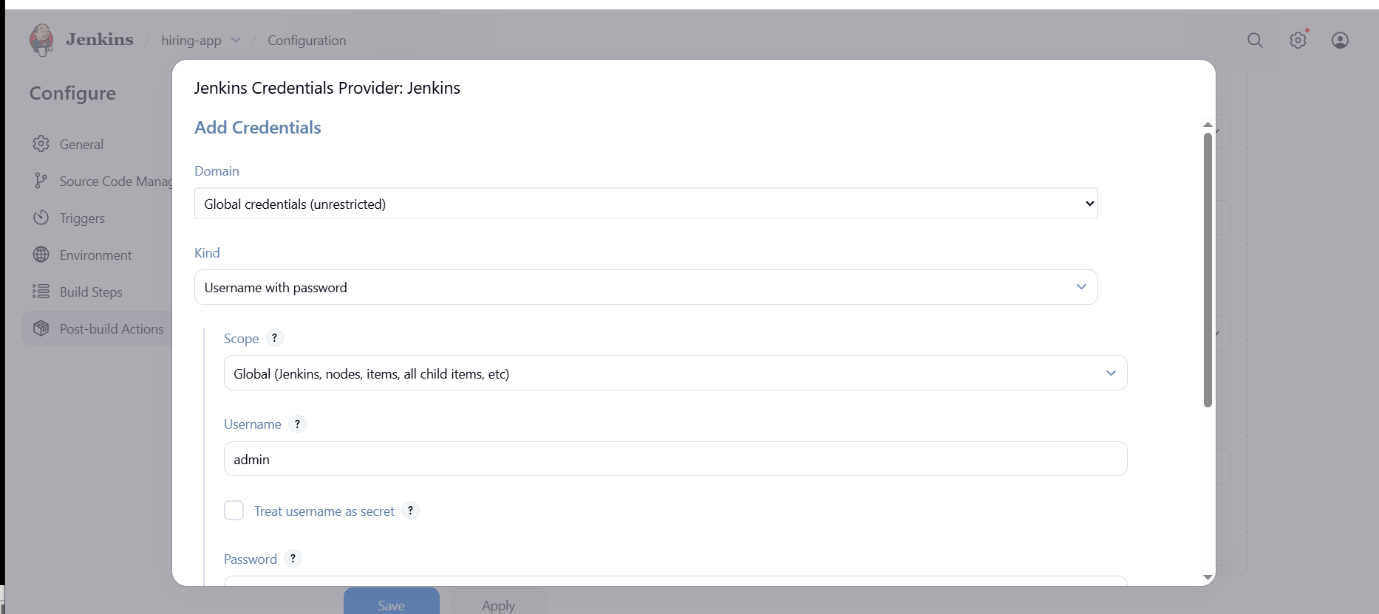
- Add details and credentials also admin, admin123
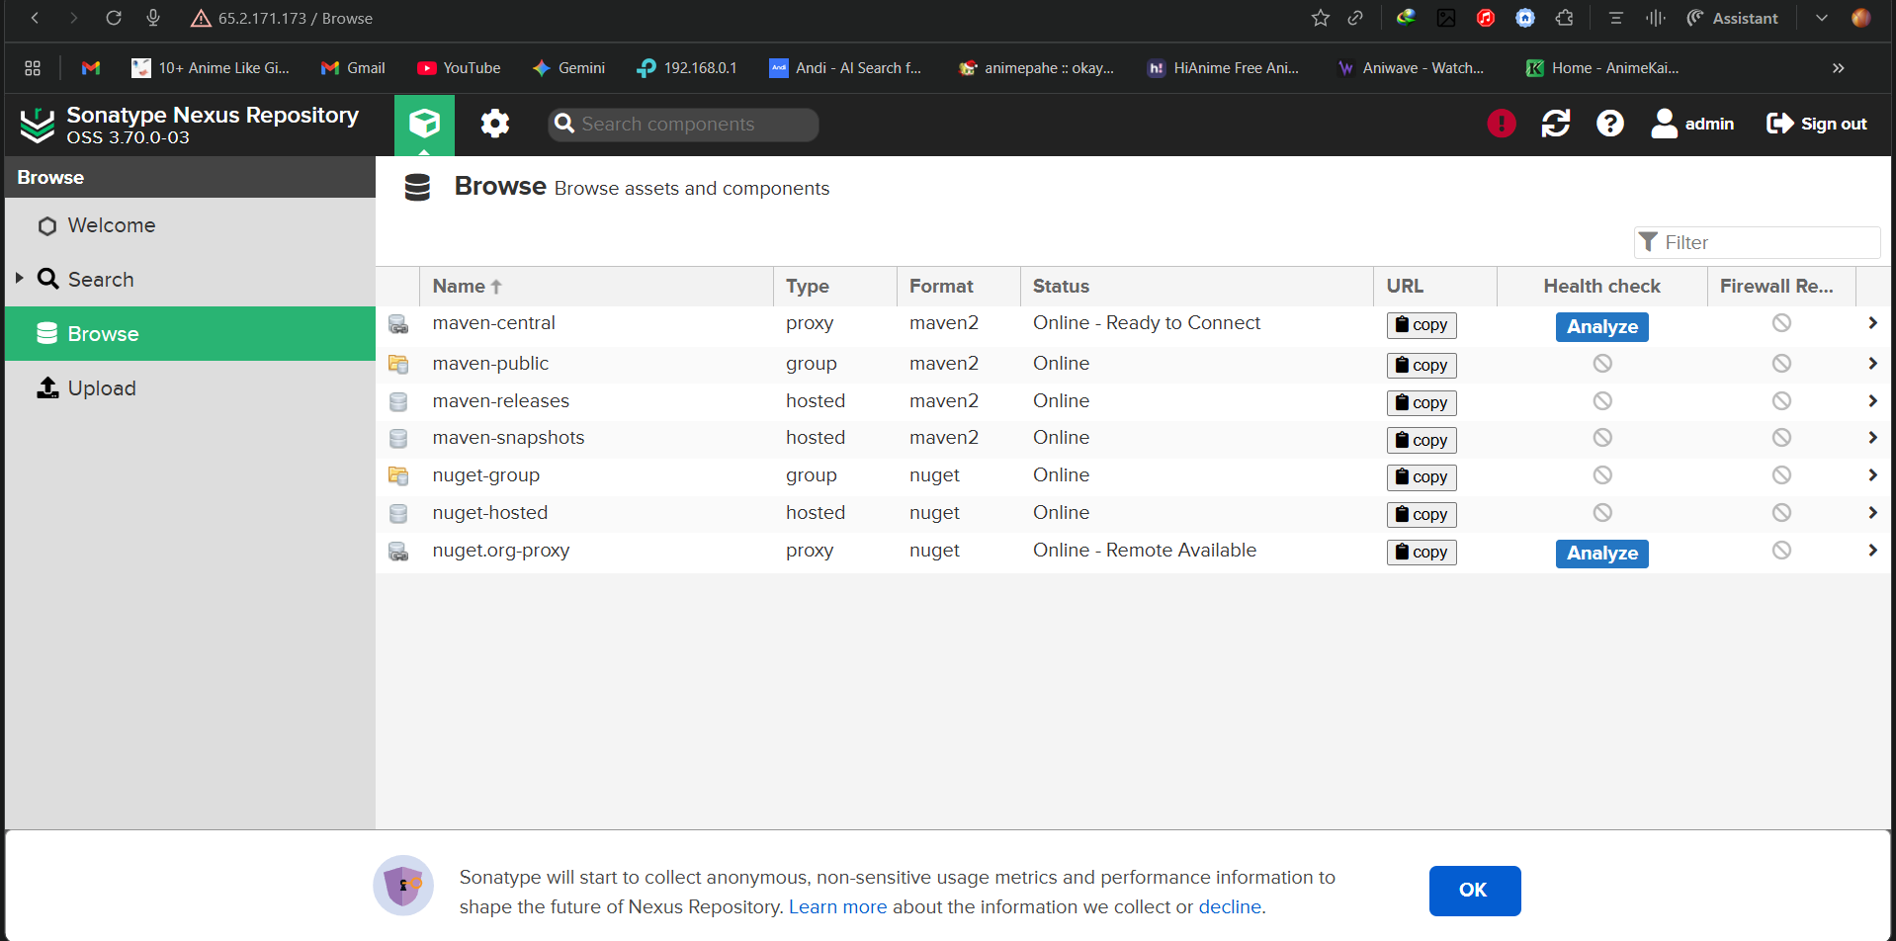
- In git hub repo in pom.xml file we have some info group id and version, bring and enter here and goto nexus create repository → maven2(host) and take release.

- By checking git repo pom.xml need to fill details give file name → /var/lib/jenkins/workspace/hiring-app/target/hiring.war
- And save try to build.
- Now run build

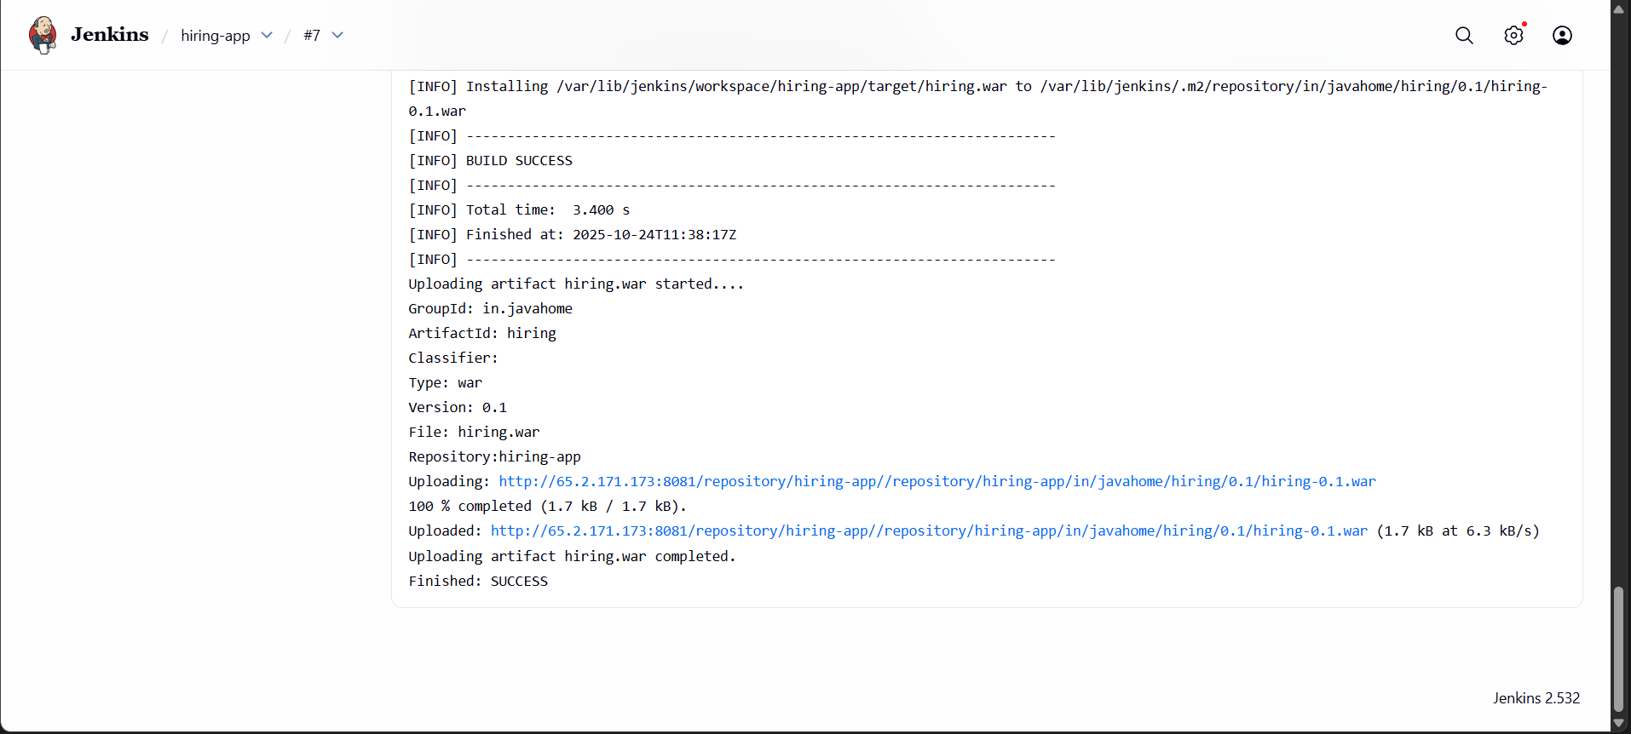

- You can check in nexus the war file

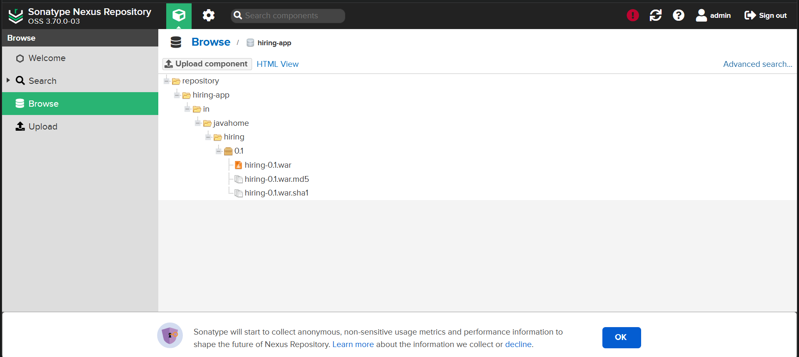

5) Slack Notification

- In jenkins download slack plugin
- In your slack channel see apps add jenkins ci , and add channel and copy the id

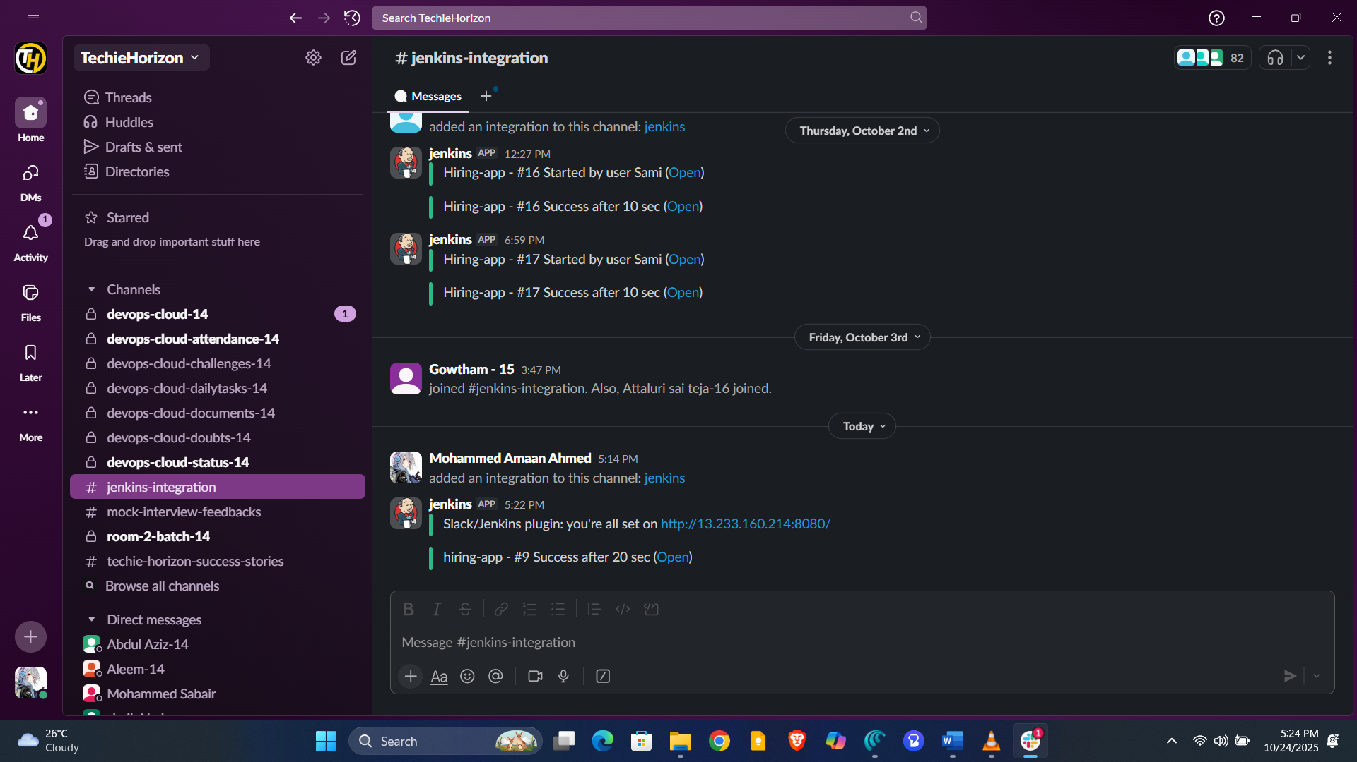

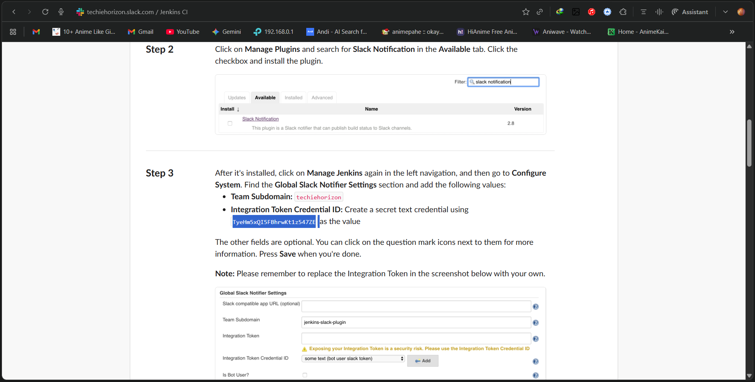

6) Deploy On tomcat

- Go to jenkins page Install plugin → deploy to container
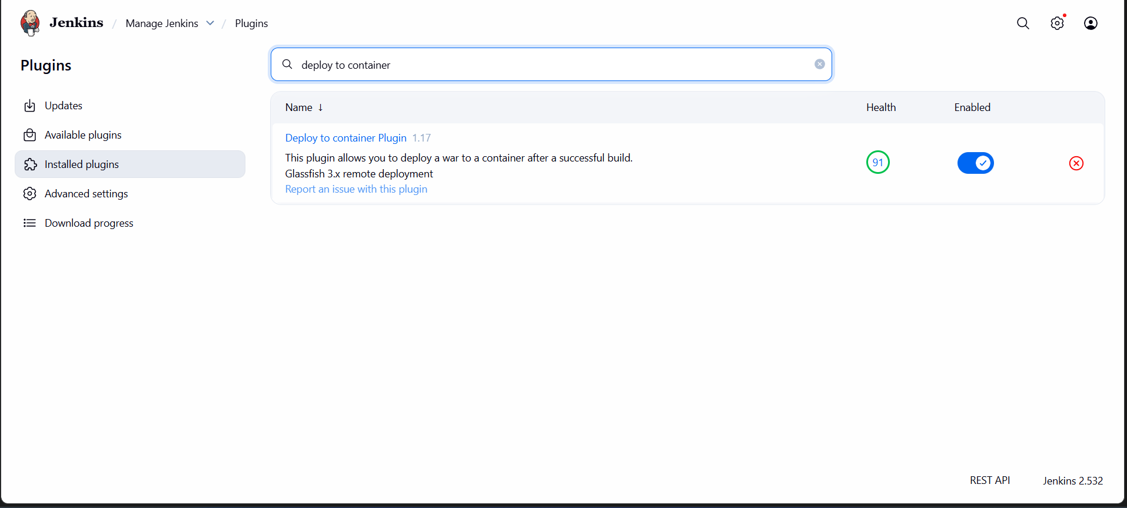

- Now create tomcat-ec2 and install tomcat.
- yum install -y java-1.8*
cd /opt
wget https://dlcdn.apache.org/tomcat/tomcat-9/v9.0.108/bin/apache-tomcat-9.0.108.tar.gz
tar xvf apache-tomcat-9.0.108.tar.gz
sudo mv apache-tomcat-9.0.108 /opt/tomcat
sh /opt/tomcat/bin/startup.sh

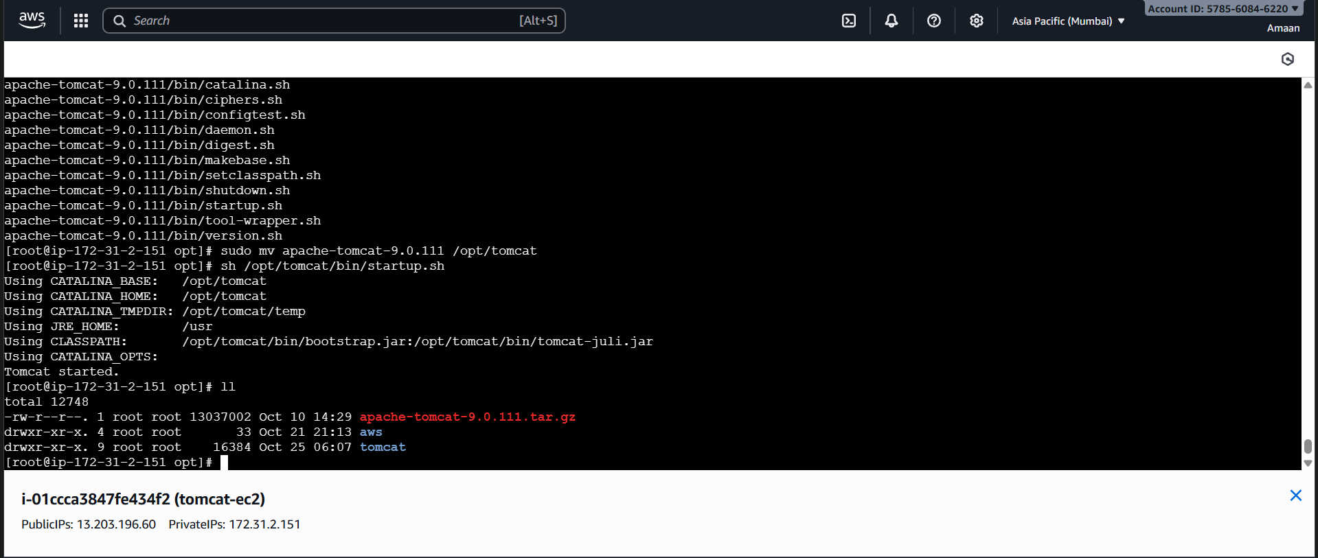

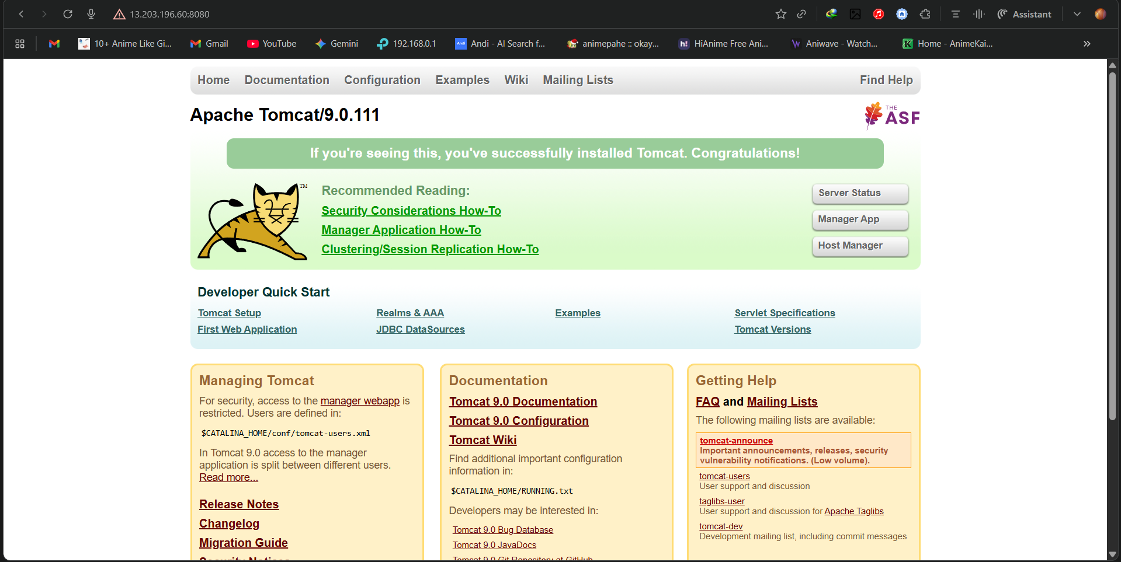

- Now create user in tomcat.
- find / -name context.xml
- Take file webapps and edit for uncomment the four files
- vi /opt/tomcat/webapps/docs/META-INF/context.xml
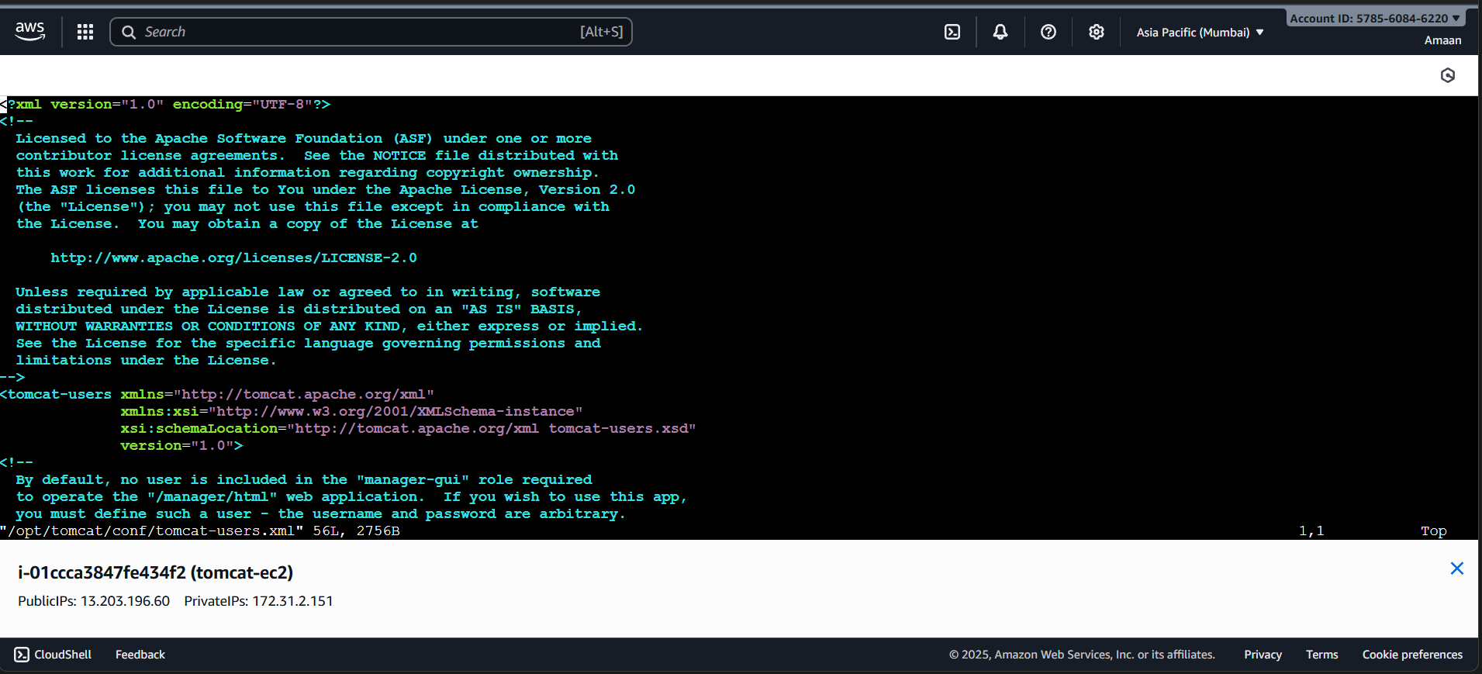

- vi /opt/tomcat/webapps/examples/META-INF/context.xml

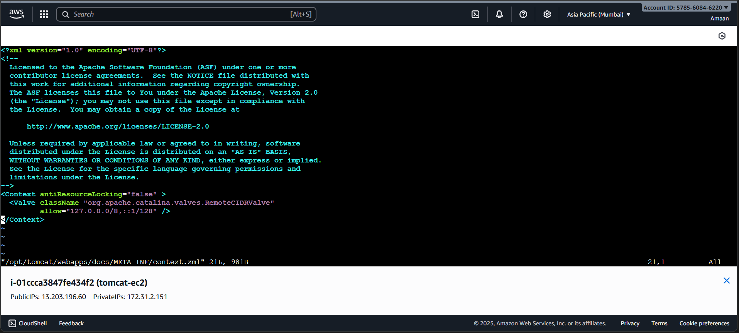

vi /opt/tomcat/webapps/host-manager/META-INF/context.xml

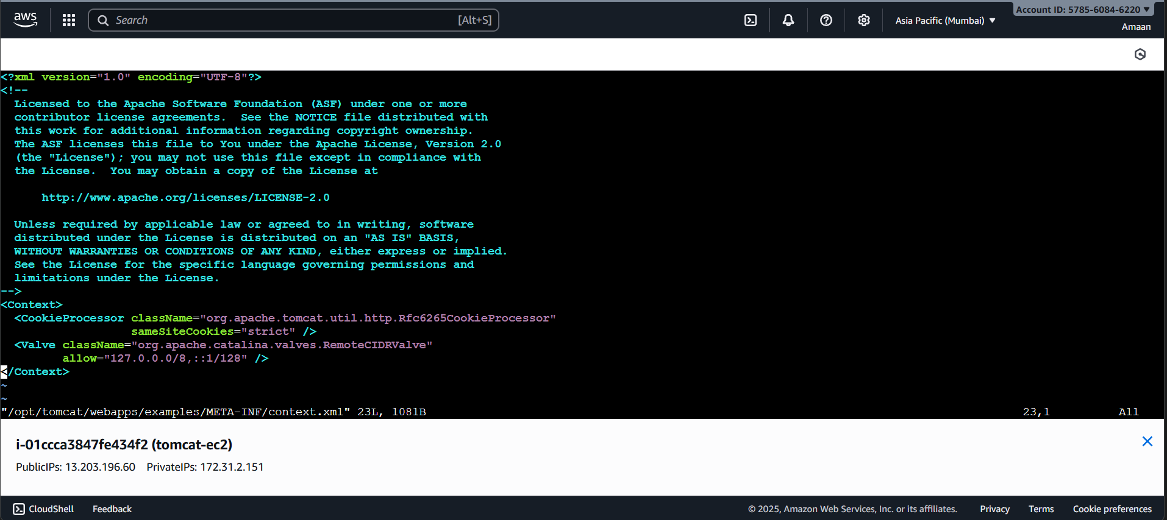
vi /opt/tomcat/webapps/manager/META-INF/context.xml

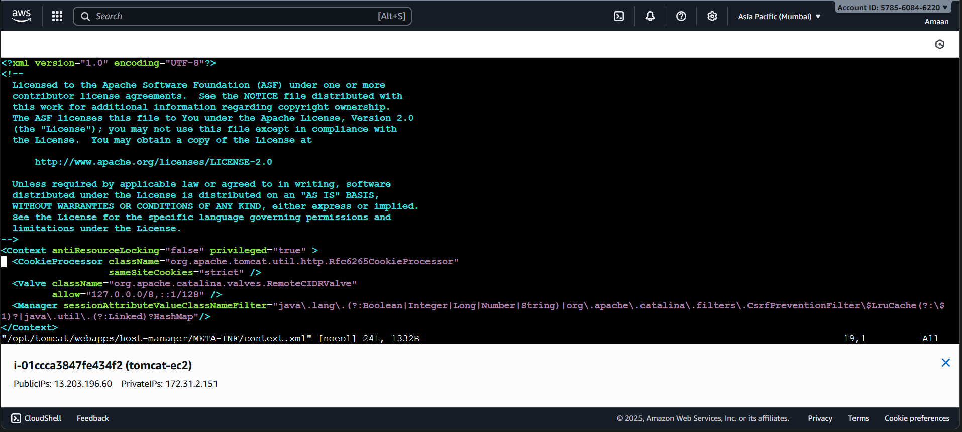

- Now goto conf in xml file add the below user details as shown in box.

cd /opt/tomcat/conf
vi tomcat-users.xml

<role rolename="manager-gui"/>
<role rolename="manager-script"/>
<role rolename="manager-jmx"/>
<role rolename="manager-status"/>

<user username="admin" password="admin" roles="manager-gui,manager-script,manager-jmx,manager-status"/>
<user username="deployer" password="deployer" roles="manager-script"/>
<user username="tomcat" password="s3cret" roles="manager-gui"/>

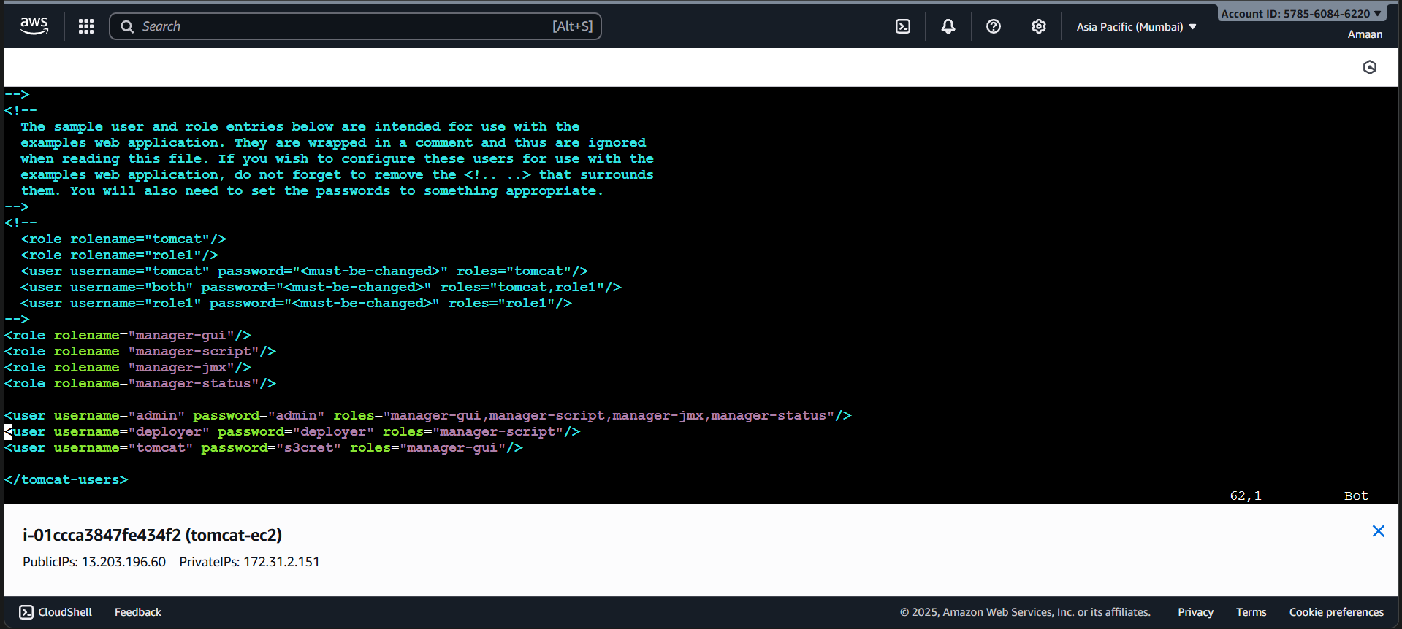

- sh /opt/tomcat/bin/shutdown.sh
- sh /opt/tomcat/bin/startup.sh
- Now in web page click on server status

Enter user deployer , password deployer

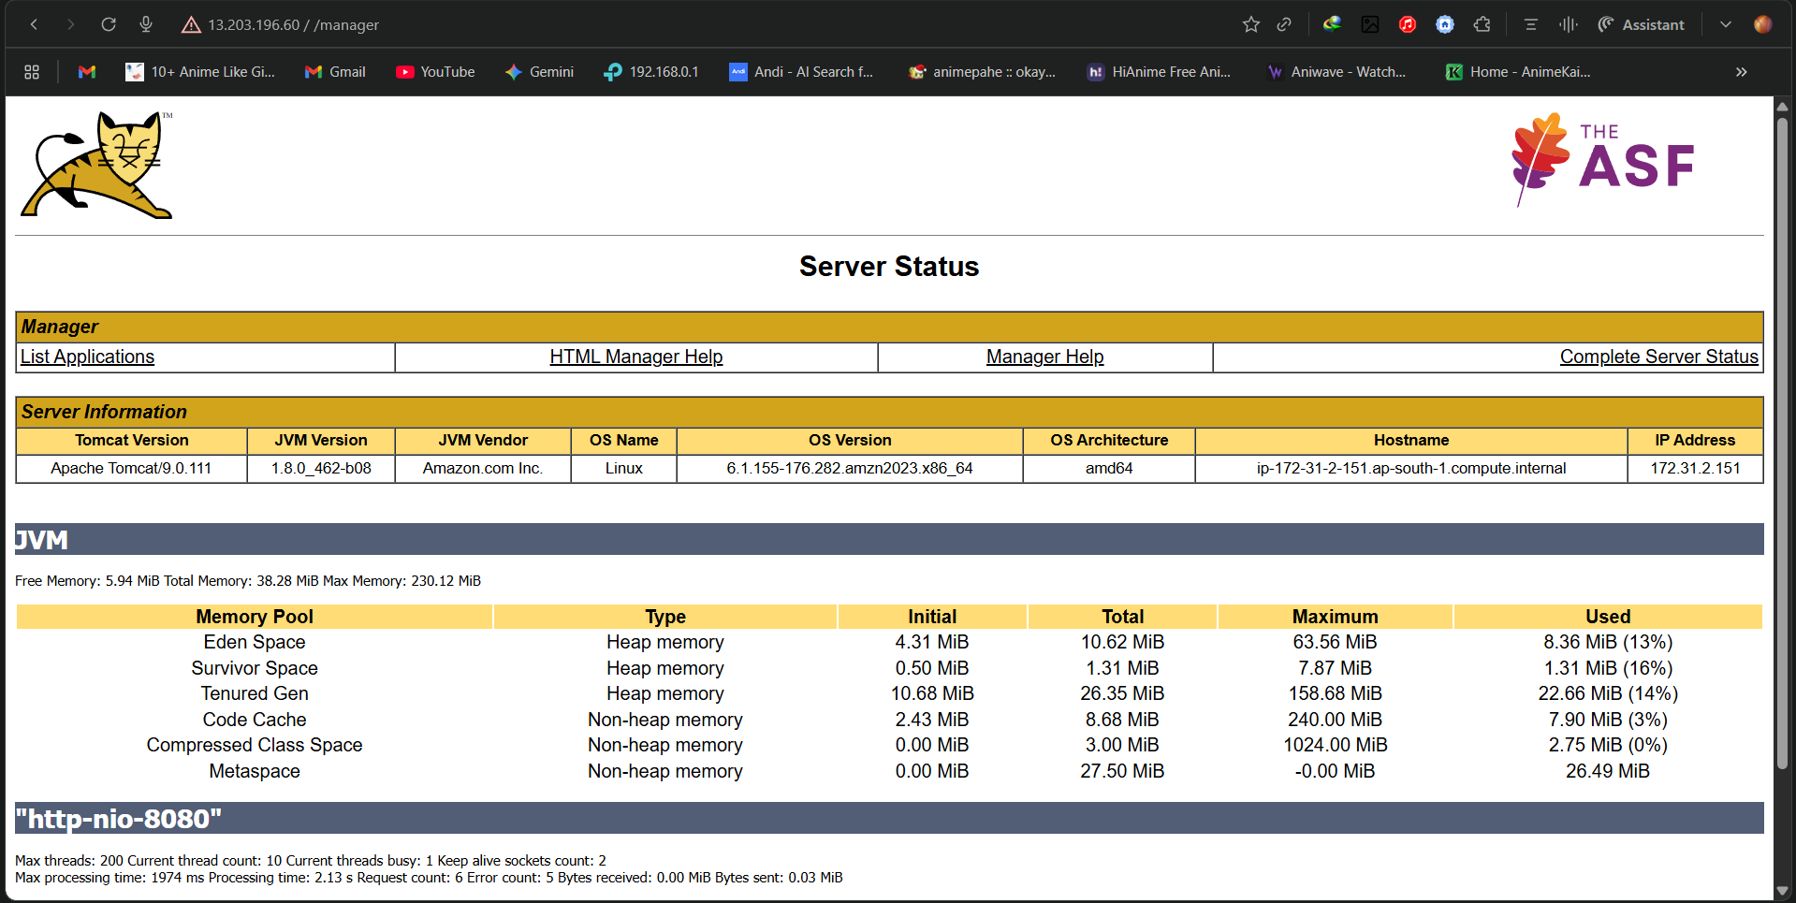

- Just go to jenkins add these credentials deployer and take WAR/EAR files as **/*.war

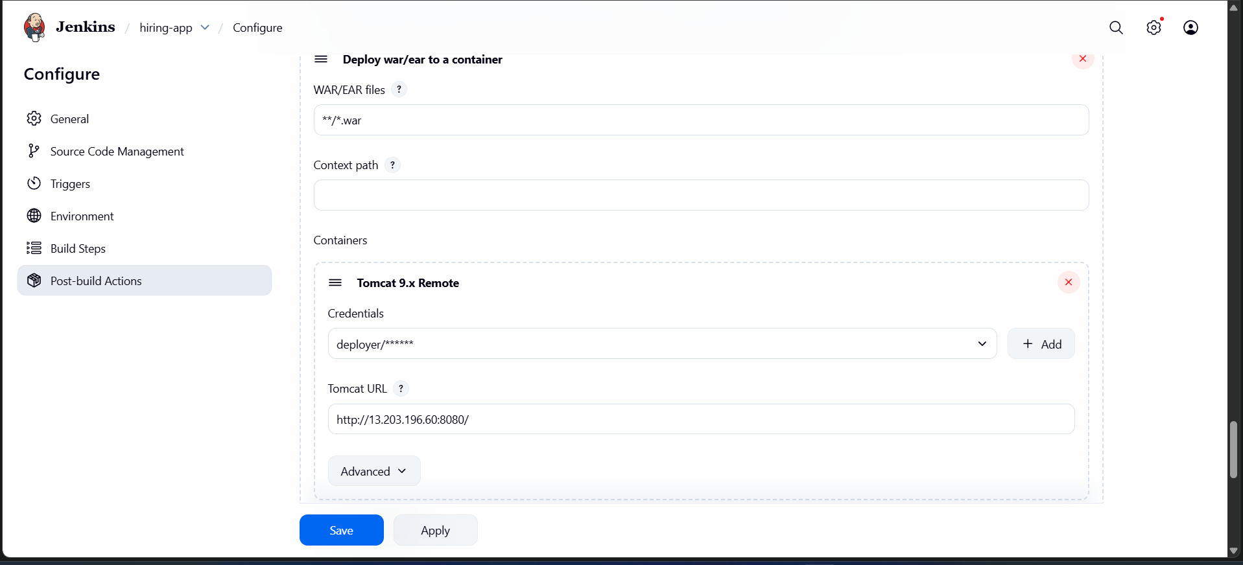

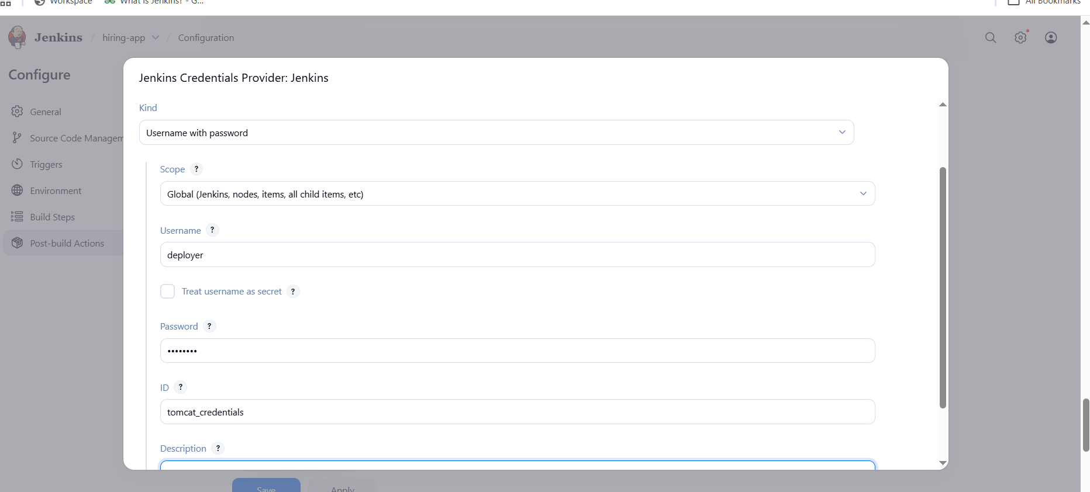
- Now our deployment successfully done
- Now you can check in tomcat cli webapps one file is shown
- Cd /opt/tomcat/webapps/hiring
- 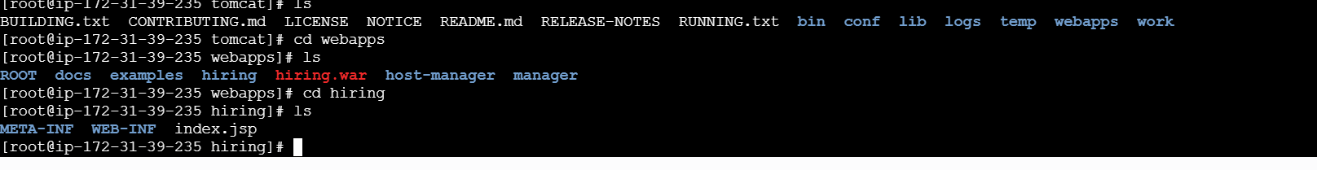
- And you can check in tomcat at browser we got our application is live.
- http://3.90.140.56:8080/hiring/
- And you can confirm the content by checking git repo code.
- 